**HOUSTON INDEPENDENT SCHOOL DISTRICT**

ROSS SHAW STERLING AVIATION HIGH SCHOOL

11625 MARTINDALE **-** HOUSTON, TEXAS 77048

TEL (713) 991-0510  **-** FAX (713) 991-8111



Sabrina V. Cuby-King, Principal

To: Parents of Students Attending Ross S. Shaw Aviation Early College High School

Subject: 2020-2021 Title 1 Status Notification

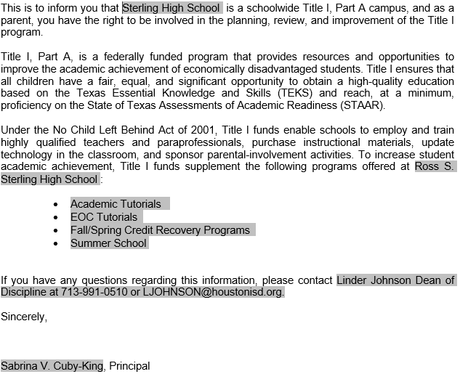



**HOUSTON INDEPENDENT SCHOOL DISTRICT**

ROSS SHAW STERLING AVIATION HIGH SCHOOL

11625 MARTINDALE **-** HOUSTON, TEXAS 77048

TEL (713) 991-0510  **-** FAX (713) 991-8111 

Sabrina V. Cuby-King, Principal

To: Padres de alumnus que asisten a la escuela Ross S. Shaw Aviation Early College High School

Subject: Adviso de Estatus Titulo 1 Para La Temporada Escuela 2020-2021

